SOT FQR MIGRATION SSIS JOBS TO ID-JKT-SQL2016

STATUS = DONE

1. Create two new database for duplication postgre data

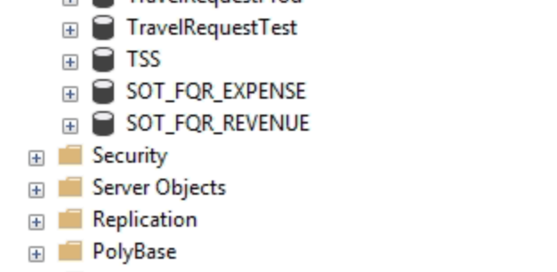

1. Create SSIS Projects packages SOT/SOTFQR.Staging

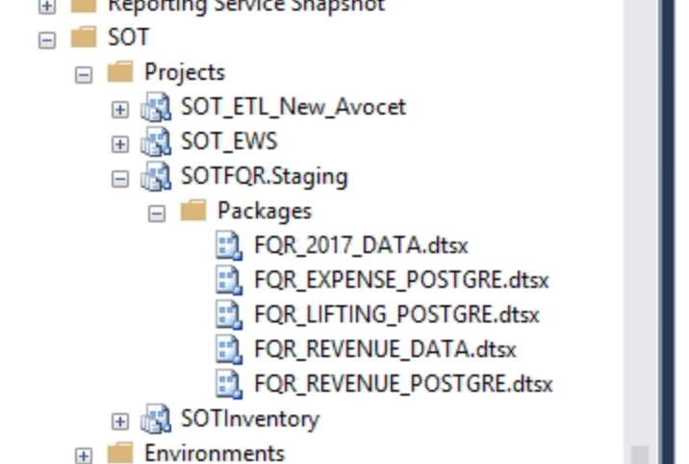

1. Create SQL JOBS for executing SSIS SOTFQR

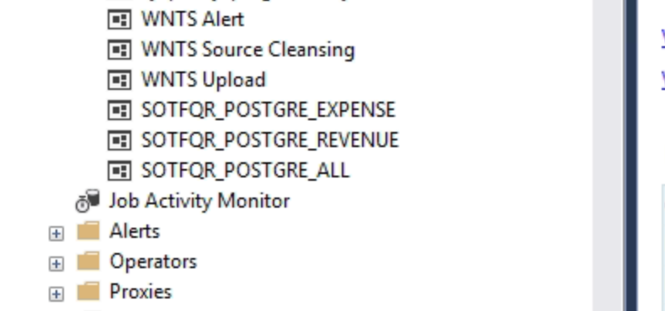

1. SQL Jobs Execution Status Report

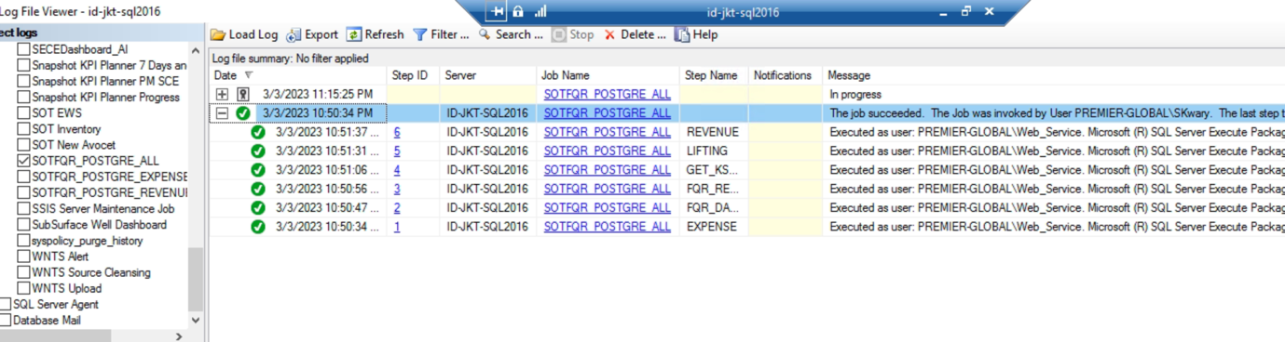

1. Related Installer Files at D:\SSIS\SOTFQR

